Minutes of the Annual Parish Council meeting held on
Wednesday 8th May 2024 at 7.00pm at
Bradley Village Hall, Church Lane, Bradley ST18 9DY

Attendees
Cllr P Oxley (Chairman) Cllr M Rossi (Vice Chairman) Cllr M Newman
Cllr R Turner Cllr L Phillips Cllr Matt Yarwood Cllr M Winnington – SCC Clerk – Nikola Evans

1 | To Elect a new Chairman of Bradley Parish Council  - Newly elected chairman to sign the declaration of office to Chairman. LGA 1972 s83(4)(a)  RESOLVED to elect Cllr P Oxley as chairman for Bradley Parish Council
2 | Election of Vice Chairman  RESOLVED to elect Cllr M Rossi as vice chairman for Bradley Parish Council
3 | To receive Apologies  Cllr T Luck – other commitments, accepted.
4 | Minutes of the last meeting – 12th March 2024  Approved as a true record by all that attended
5 | Declaration of Interests on agenda items – None received
6 | To adjourn parish council meeting to allow for public participation – None attended
7 | To receive reports from Stafford Borough Councillor and Staffordshire County Councillor  No Stafford Brough Councillors attended, Cllr M Winnington from Staffordshire County Council reported on the following:  - Broadband providers are causing disruption within the village, but it is necessary works and will benefit the community once its finished.  - The county council and highways are aware the roads are very bad, Cllr Winnington is pushing for repairs.  - HGV sign on Bradley Lane should be installed soon.
8 | To receive reports on any new footpath, village maintenance or highways issues.  None received
9 | To receive report on outstanding planning applications  No changes
10 | Consideration of new planning applications  None received
11 | To review the following policies  - Standing Orders – LGA 1972, s135 – reviewed, no changes made, approved.  - Financial Regulations – LGA 1972, s151 – Adopted new regulations  - Asset Register – Accounts and Audit Regulations 2015 – reviewed and approved  - Risk Assessment for the Parish council and its functions. (Internal Control) – Accounts and Audit Regulations 2015 – Reviewed, added two new sections, business interruption and cyber security. Approved  - Scheme of delegation – LGA 1972, s101 – reviewed, no changes made, approved.
12 | Finance – RFO  - Payment approval - approved  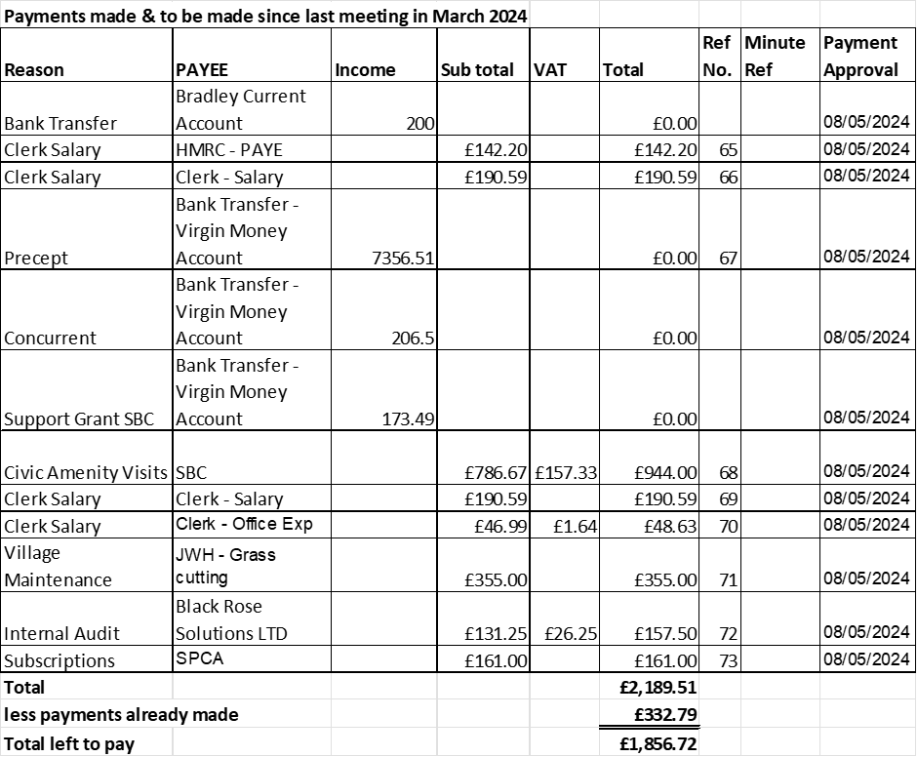  - Budget summary – circulated before and approved at the meeting.  - Bank reconciliation – circulated before and approved at the meeting.  - Circulation and approval of end of year bank reconciliation 2023/24 – circulated before and approved at the meeting.  - Circulation and receipt of Internal Audit 2023/24 – circulated before and approved at the meeting.  - Approval of Annual Governance Statement 2023/24 - approved  - Approve Accounting Statements 2023/24 - approved  - Approve Certificate of Exemption 2023/24 - approved
13 | To consider request from St Mary an All-Saints Church for an increase in the annual grant which is currently set at £750.  Requested further information, a breakdown of what the money is spent on, Cllr M Rossi to action.
14 | To consider increasing grass cutting on Malthouse Lane, Elm Drive, Holly Lane corner of Church Lane and Bradley Lane. Wells Dairy have offered to cut in between our nominated contractor or make a donation. Current schedule is every 6 weeks = 6 cuts between March – November.  The parish council resolved to leave the grass cutting schedule as it is, clerk to accept the offer from Well’s Dairy for a monitory donation, clerk to action.
15 | Councillor Information and items for the next Agenda  Cllrs are invited to give reports on parish issues which do not require a resolution.  Cllr Newman advised the traffic survey had been commissioned, the box had been installed and was awaiting approval, the survey will take place soon. He requested reports on the actions from previous minutes  - Item 10a(i) – Footpath working group – it was agreed the clerk would produce literature to be placed on the website advising users of walking etiquette. Clerk advised this action had been missed and would revisit.  - Item 10c – Gateway features, it was agreed to investigate planters instead, Cllr Luck and clerk to action, Cllr Luck did not attend tonight’s meeting to give an update. Deferred to next meeting, clerk to contact highways and remind Cllr Luck.  - Parish council website – Ongoing, Cllr Phillips continues to look at ways to improve the site. Clerk to contact village groups to see if they want a dedicated page.
16 | To agree date of next meeting – 9th July 2024 @ Bradley Village Hall, from 7.00pm  - Future meeting dates – 10.09.24, 12.11.24 – all from 7pm
17 | Meeting Closed – 21.30pm

