**Bradley Parish Council – January 2024**

**USEFUL INFORMATION**

|  |  |
| --- | --- |
| **Report Highways issues**  <https://apps2.staffordshire.gov.uk/web/reportfault/#divSelectionHeader> | **Map of footpaths and bridleways**  https://www.staffordshire.gov.uk/environment/RightsofWay/Footpaths-bridleways.aspx |
| **Report Stafford Borough Council Issues**  https://www.staffordbc.gov.uk/streetscene-to-report-a-problem-make-a-comment-or-complaint | **Bradley Parish Council**  [clerk-bradleypc@hotmail.co.uk](mailto:clerk-bradleypc@hotmail.co.uk), 45 Thorn Close, Brereton, Rugeley WS15 1TA – 07971226170 or alternatively, the parish council’s website <https://www.bradleypc.co.uk> |
| **Call 101 to report a crime that has already happened or on line, on the Staffordshire police website** <https://www.staffordshire.police.uk/ro/report/ocr/af/how-to-report-a-crime/> . | **To get up to date information regarding crime in your local area.** <https://www.staffordshire.police.uk/area/your-area/staffordshire/stafford-borough/south-west-stone/about-us/top-reported-crimes-in-this-area> |
| **Receive the latest community safety information alerts about what's happening in your local area by registering for Staffordshire Smart Alert.** <https://www.staffordshire.police.uk/advice/advice-and-information/wsi/watch-schemes-initiatives/as/staffs/staffordshire-smart-alert/> | **Walks around Bradley Village** – There are 8 known walks all maps are available on our website <https://www.bradleypc.co.uk/about-the-parish/walks-around-bradley/> |

**AMENITY VISITS 2024**

**PARISH COUNCIL MEETINGS**

|  |  |
| --- | --- |
| 9th January 2024 | From 7.30pm |
| 12th March 2024 | From 7.30pm |
| Annual parish council meeting  14th May 2024 | From 7.30pm |
| Annual public meeting 2024 – TBC | TBC |
| 9th July 2024 | From 7.30pm |
| 10th September 2024 | From 7.30pm |
| 12th November 2024 | From 7.30pm |

**MEETING SUMMARY - PCM – 14th November 2023**

**General**

1. A new dog waste bin has been purchased and the parish council is in receipt, look out for it to be installed shortly, next to the general waste bin on Malthouse Lane.
2. In conjunction with The Bradley Trust. A memorial tree and plaque have been planted to mark a much valued and loved member of the Bradley community, Betty Metcalf. The location is between Malthouse Lane and Elm Drive by the footpath, should anyone wish to view.
3. Lookout for a new section on our website, <https://www.bradleypc.co.uk/> It will be full of information on what you can do to combat sustainability.
4. The parish council have been doing some work to reinstate the traditional wooden black and white fingerposts. The current ones have been cleaned by Cllr Rossi and Cllr Luck, they look fantastic, a broken fingerpost has been removed by Cllr Turner and the parish council will look into the cost of replacing any that are needed.
5. A new sign has been approved out of Cllr M Winnington’s (your local County Councillor) budget, for better signage on Bradley Lane/A518, in both directions. The sign will be advising, the lane is not suitable for heavy goods vehicles, it will be installed by March 24.
6. The parish council is working with the remaining members of the Friendship Circle to plant a tree in dedication to all the great work they did within the community.

**Village maintenance**

The parish council have accepted a quotation from JWH Grounds Maintenance for 2024. The areas the parish council will be concentrating on are, Malthouse Lane, Holly Lane, Elm Drive, the corner of Church Lane & Bradley Lane and the play area. The parish council will monitor the situation over the next year to determine if extra cuts are required.

Highways seem to be getting on top of some of the issues within the village. Potholes and sign posts continue to be reported and chased, however if you have any concerns, please do not hesitate to contact the clerk.

The clerk will report the gully’s on the A518, at the first bend by Alstone Lane. The area is well known for flooding.

**Bradley Community Plan** – An updated copy can be viewed on the parish council website, following the last meeting on 14th November the parish council will be considering the following:

1. Reinstating the red telephone box – This has been deferred to next meeting in January 2024.
2. Improve signposting of public footpaths – It was suggested a footpath committee could be organised, to walk the routes and make a list of the issues for the parish council to consider.
3. Gateway features to the village – The parish council are considering locations and the cost of installing three gateways as you enter the village, replacing the existing “Welcome to Bradley” signs.

Items for discuss at the next meeting on 9th January 2024, off the Bradley Community Plan, will be:

1. Populating the current parish council website with links to other services, to create a one-stop website for the community.

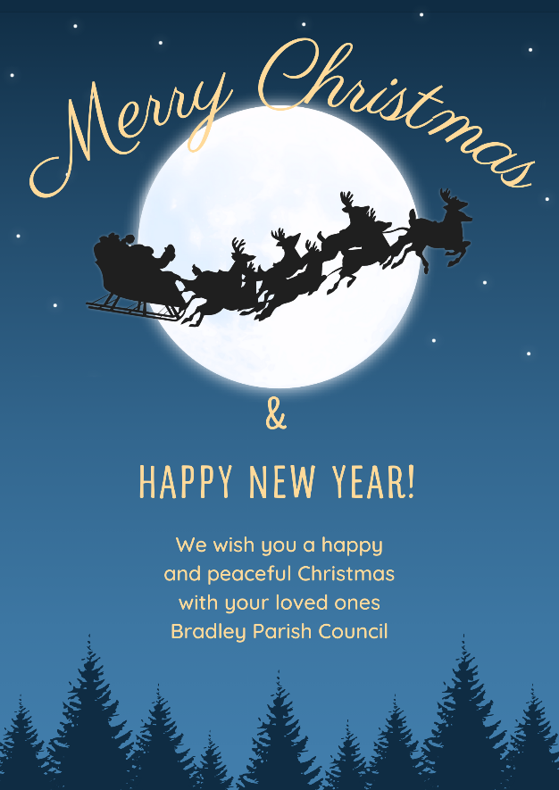Ta ta for now, See you in 2024!