Minutes of the parish council meeting held on
Tuesday 14th January 2025 at 7.00pm at
Bradley Village Hall, Church Lane, Bradley ST18 9DY

Attendees
Cllr P Oxley (Chairman) Cllr M Newman Cllr T Luck Cllr M Yarwood
Clerk – Nikola Evans Cllr M Winnington – SCC

1 | Declaration of Interests on agenda items  None declared
2 | To receive Apologies  Cllr Rossi – Other commitments  Cllr Philips – Sick  Cllr Turner – No apologies
3 | Minutes of the last meeting – 12th November 2025  Cllr Luck – proposed, Cllr Yarwood – 2nd. RESOLVED as a true record
4 | To adjourn parish council meeting to allow for public participation  - Public participation - Members of the public are invited to address the Council on any issue over which it has power for up to 5 minutes each, with the item lasting a maximum of 20 minutes.  - Stafford Borough Councillor – None attended  - Staffordshire County Councillor – Cllr Winnington reported on the following:  - Flooding & Potholes – SCC are aware of the conditions, Cllr Winnington will keep chasing the community officers. He encourages residents to keep reporting issues.  - Possibility of having a unitary council, SCC will still exist in some form, however SBC will disappear. Cllr Winnington advises parish council to keep an eye out for any consultations.  - Parish council asked for an update on signage for Holly Lane, Cllr Winning wasn’t able to advise at this meeting, clerk to send Cllr Winnington a reminder to chase ready for the next meeting.
5 | Matters arising from previous minutes  - Affordable Rural Housing – update from public meeting held on 21st November 2024 – Parish council agreed to defer to the next meeting when more councillors are present, it was also agreed clerk will send “Parish Council’s Guide to Rural Housing” to the councillors, and ask the enabling officer to provide further information on the housing needs survey.  - Play area lease – update –The Bradley Trust will take back ownership from 1st April 2025. Any assets will be donated to The Bradly Trust. Clerk to organise.  - Clerk to chase item 8b 21.11.24 - Old Fosters site – The protruding wall onto highways is still there, clerk to chase claims team for an update.
6 | To receive report on outstanding planning applications  Application Number Site Address Proposed Development Action  24/38563/FUL Eaton Brook Farm Woollaston Lane Church Eaton Conversion of an agricultural barn to a residential unit including the alteration and upgrade of fabric to accommodate new windows & doors and the construction of new garage entrance gates and boundary walls and associated patio, outdoor kitchen and amenity spaces. Awaiting decision  24/39280/ANX The Grove Wells Lane Bradley ST18 9EE Conversion of outbuilding to granny annexe with accessible wetroom Awaiting decision  24/38841/FUL Land Opposite Greenhouse Mitton Road Bradley Stafford Staffordshire Change of use of land for the re-siting of approved self-storage containers to be used by enterprise on site and private business uses, addition of solar panels and new access Awaiting decision
7 | Consideration of new planning applications  None to consider
8 | To receive reports on any new footpath, village maintenance or highways issues  Potholes on Wells Lane, Upper Barton Farm, Cllr Winnington will chase.
9 | Finance – RFO  - Payment approval - approved  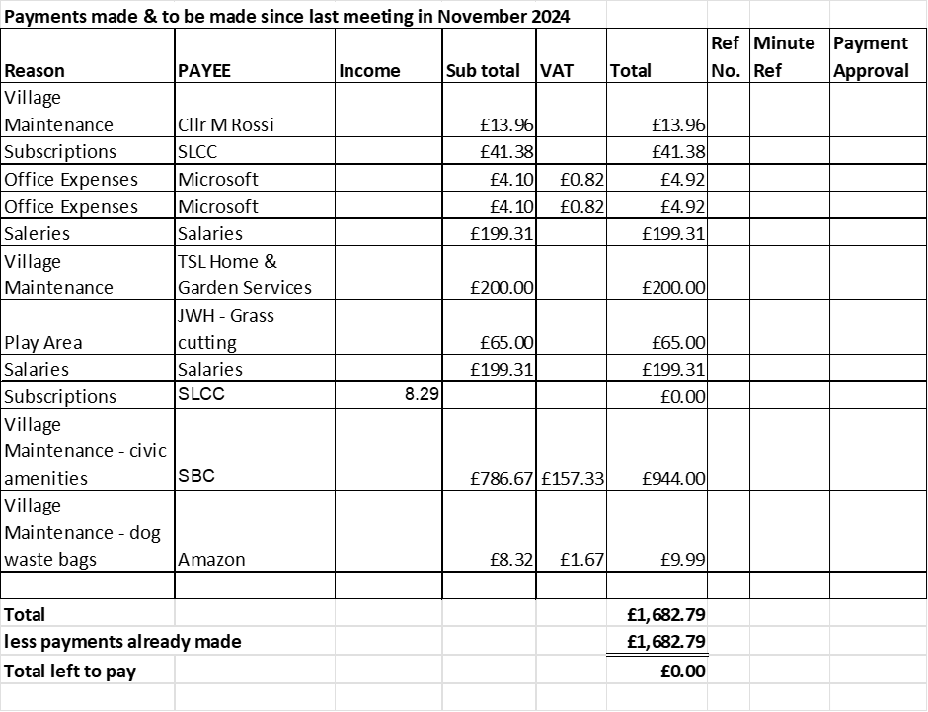  - Budget summary – Circulated and approved  - Bank reconciliation – Circulated and approved
10 | Councillor Information and items for the next Agenda  Cllrs are invited to give reports on parish issues which do not require a resolution.  - It was reported The Red Lion has been brought by Davenport Brewery, due to re-open in February.  - A planter has been installed by the “Welcome to Bradley” sign on Bradley Lane, planter was kindly donated by TSL Home & Garden Services.  - The parish council website has been updated to include a community area, it will show links to different community groups in the village.  Items for next agenda:  - Considerations on new projects within the village.
11 | To agree date of next meeting –  - 11th March 2025, from 7pm at Bradley Village Hall  - April date TBC – Annual Public Meeting  - 13th May 2025 – Annual Parish Council Meeting  - 8th July 2025  - 9th September 2025  - 11th November 2025
12 | Meeting Closed 19:55

