Minutes of the parish council meeting held on
Tuesday 10th September 2024 at 7.00pm at
Bradley Village Hall, Church Lane, Bradley ST18 9DY

Attendees
Cllr P Oxley (Chairman) Cllr M Rossi (Vice Chairman) Cllr M Newman
Cllr R Turner Cllr L Phillips Cllr T Luck
Cllr M Yarwood Clerk – Nikola Evans

1 | Declaration of Interests on agenda items  None Received
2 | To receive Apologies  Cllr M Winnington – SCC  Cllr J Rose - SBC
3 | Minutes of the last meeting – 9th July 2024  Proposed – Cllr T Luck  Second – Cllr M Yarwood  Approved as a true record by all that attended
4 | To adjourn parish council meeting to allow for public participation  - Public participation - Members of the public are invited to address the Council on any issue over which it has power for up to 5 minutes each, with the item lasting a maximum of 20 minutes.  None attended  - Stafford Borough Councillor  None  - Staffordshire County Councillor  None
5 | Matters arising from previous minutes  - Planters, Bradley Lane  Ok to go ahead and place a planter, Staffordshire County Council have advised there will be no need for a section 50 licence. Approved for TSL Home & Garden Services to provide low level planter and contents. Budget agreed £500, clerk to action. TSL will maintain.
6 | To receive report on outstanding planning applications  Application Number Site Address Proposed Development Action  21/34168/FUL The Site of The Old Cottage, Almshouse Croft, Bradley Stafford Amendment to plans – this plan has now been changed back to the original plan. 18/29029/FUL - Allowed Withdrawn Application  24/38563/FUL Eaton Brook Farm Woollaston Lane Church Eaton Conversion of an agricultural barn to a residential unit including the alteration and upgrade of fabric to accommodate new windows & doors and the construction of new garage entrance gates and boundary walls and associated patio, outdoor kitchen and amenity spaces. Awaiting decision  24/39280/ANX The Grove Wells Lane Bradley ST18 9EE Conversion of outbuilding to granny annexe with accessible wet room Awaiting decision  24/38841/FUL Land Opposite Greenhouse Mitton Road Bradley Stafford Staffordshire Change of use of land for the re-siting of approved self-storage containers to be used by enterprise on site and private business uses, addition of solar panels and new access Awaiting decision
7 | Consideration of new planning applications  - 24/38841/FUL – Land opposite Greenhouse, Mitton Rd, Bradley. Proposed as change of use of land for the re-siting of approved self-storage containers to be used by enterprise on site and private business uses, addition of solar panels and new access.  No objections submitted
8 | To receive reports on any new footpath, village maintenance or highways issues  - To discuss hot spot areas for environmental to provide some preventative work for dog fouling. - There are no particular hot spots. Approved for Cllr Rossi to purchase dog fouling stickers for the community.  - Place an article in the Bugle, advising dog owners of the risks if they don’t pick up their dog waste.  - It was reported highways had visited the bottom of Elm drive on Holly Lane, and were measuring the width of the road and signs. Clerk to ask our local highways officer if there was any information that they could provide as to the reason why?
9 | Finance – RFO  - Payment approval – Finance report circulated before the meeting. - APPROVED  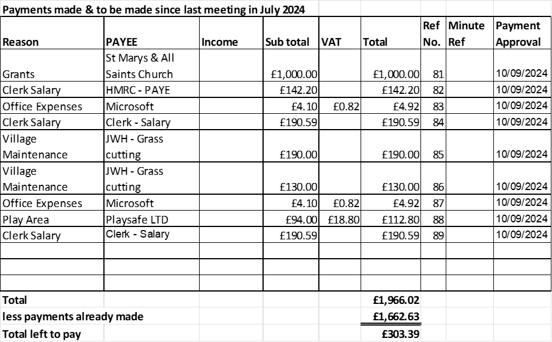  - Budget summary – Finance report circulated before the meeting. - APPROVED  - Bank reconciliation – Finance report circulated before the meeting. - APPROVED
10 | To adopt new Grievance and Disciplinary Policy – August 2024  Amend as necessary and present at the next meeting for formal adoption, clerk to action.
11 | To discuss changing emails to gov.uk domains as recommended by National Association of Local Councils  Recommended by National Association of Local Councils (NALC) Clerk presented the parish council with a quotation of £50 a year for Staffordshire ICT Digital Team at Staffordshire County Council. Approved to go ahead, clerk to action.
12 | To discuss and approve play area inspection costs and necessary remedial work identified in the recent inspection.  - Approved repairs to be carried out by TSL Home & Garden Services.  - Clerk presented the parish council with a quotation from RoSPA Play Safety Ltd, for 4 inspections a year totalling £858. The parish council wondered if there was any movement on the cost if they join forces with other local parishes to carry out the inspections on the same day to try and keep the cost down. Clerk to contact other parishes.
13 | To approve costs for rewilding area maintenance  Approved quotation received from TSL Home & Garden Services, £200 for man and rotavator for 1 day.
14 | To consider the possibility of affordable rural housing for locals  Clerk to contact local planning officers for more information.
15 | Councillor Information and items for the next Agenda  Cllrs are invited to give reports on parish issues which do not require a resolution.  - Community shop – Cllr M Newman  Cllr Newman shared a possible Beautiful Bradley Group project; they will be investigating the need for a local community shop within Bradley. It will be a not-for-profit organisation; any profit will be put back into the community, and it will be run by volunteers. Once they have all the information they would like to approach the parish council for support.
16 | To consider purchasing dog mess scoops for the village.  Approved to purchase 5 dog poo dispensers, plus bags, to replace the existing temporary ones installed by a local resident. Clerk presented the council with an approximate cost of £200. Clerk to action.
17 | To agree date of next meeting –  - 12th November 2024, from 7pm at Bradley Village Hall
18 | Meeting Closed – 20:20pm

