Minutes of the Parish Council meeting held on
Tuesday 12th March 2024 at 7.00pm at
Bradley Village Hall, Church Lane, Bradley ST18 9DY

Attendees
Cllr P Oxley (Chairman) Cllr M Rossi (Vice Chairman) Cllr T Luck Cllr M Newman Cllr R Turner Cllr L Phillips – arrived late 19:23 Cllr Matt Yardwood Cllr M Winnington – SCC Clerk – Nikola Evans
1 | To receive Apologies - Cllr J Rose - SBC
2 | Minutes of the last meeting – 9th January 2024 - Approved as a true record by all that attended
3 | Declaration of Interests on agenda items – None received
4 | To adjourn parish council meeting to allow for public participation  - Stafford Borough Councillor - None  - Staffordshire County Councillor – Cllr Winnington advised the following:  - SCC have increase council tax to the maximum they can increase, 4.99%, equivalent of £1.41 per week for a band D property  - Cllr Winnington was asked for an update on the new HGV sign to be installed at the entrance Bradley Lane – Clerk to email Highways and chase, copying Cllr Winnington in.  - Cllr Winnington was asked about the state of a small stretch of road on Littywood Lane, Cllr Winnington will look into this, clerk to also contact highways.
5 | To receive report on outstanding planning applications  Application Number Site Address Proposed Development Action  22/35686/FUL Finney’s House Holiday Lodges Refused  21/34168/FUL 18/29029/FUL - Allowed The Site of The Old Cottage, Almshouse Croft, Bradley Stafford Amendment to plans – this plan has now been changed back to the original plan. Building regulations stated they had visited site and were happy with current safety Awaiting decision  23/38388/LDC Land on the site of the old cottage Almshouse Croft Bradley Lawful development certificate existing – confirmation of material commencement on 18/29029/FUL Allowed
6 | Consideration of new planning applications  - 24/386440/FUL – Fosters Foiliage by Design Ltd, Mitton Rd, Bradley – Removal of condition 4 (landscaping) on 21/35264/FUL – No objections received
7 | To receive reports on any new footpath, village maintenance or highways issues  - HGV’s travelling through the village, NAR Fencing on old fosters site.  - HGV’s travelling on Holly Lane, Wells Farm Dairy  The parish council recognise the increase in traffic, especially large vehicles traveling through the village and the increase of destruction caused to verges. Following discussions between Cllr Winnington and the Beautiful Bradley Group, he has agreed to take forward a proposal to conduct a survey which will identify speed, volume and vehicle type, travelling through the village at Holly Lane. Cllr Winnington has agreed to fund this out of his DHP. Once the results are back, possible solutions can be put forward.
8 | Finance – RFO  - Payment approval – Finance report circulated before the meeting. – Approved to pay  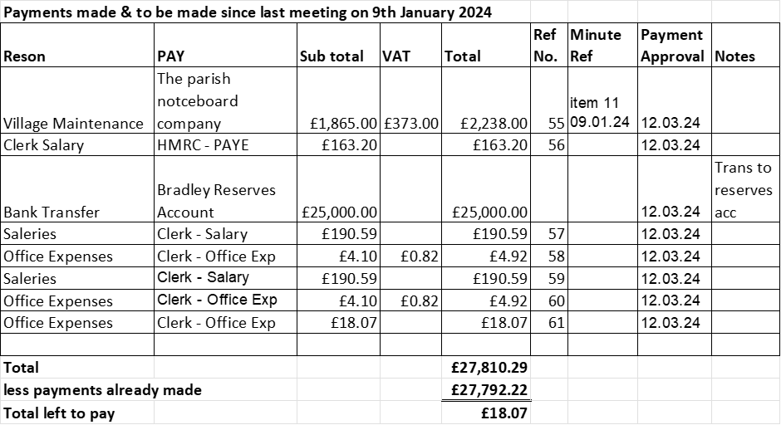  - Budget summary – Finance report circulated before the meeting. – circulated before the meeting and approved  - Bank reconciliation – Finance report circulated before the meeting. – circulated before the meeting and approved
9 | To discuss grant request from St Mary’s Church, not received since December 2021 - £750 per year.  Clerk advised the grant had been paid up until December 2022, RESOLVED to pay £750 for 2023, clerk to organise. Cllr Rossi will contact the treasurer for details.
10 | To discuss matters arising from previous minutes  - signposting of public footpaths  - footpath working group – It was agreed to produce literature advising people who use these footpaths to report any issues they may come across; the parish council can then decide how to rectify the issues. It was also agreed to include, raising awareness of walking etiquette for people doing the walks. Clerk to action.  - Gateways features to the village – RESOLVED to reject the proposal, after further investigations it was decided they would be too expensive to install, and also due to restrictions of type and location they would not be impactful enough. Alternative proposal put forward, install some low-level planters in front of the existing signs, councillors Newman and Rossi will see if anyone within the village is willing to maintain them if the proposal is carried forward. Cllr Luck will research planters, clerk to contact highways for permission.  - Populating the current parish council website with links to other services, to create a one-stop website for the community. – Cllr Phillips proposed a reorganisation of the website to simplify the look. Dividing it into three sections, parish council, community & services. Clerk to invite local groups to see if they would be interested in having a dedicated section on our website. Cllr Phillips will take the lead and work alongside the clerk.  - Update on meeting that took place between the parish council and the Bradley Trust.
11 | To discuss the outcome of the informal meeting between The Bradley Trust and Bradley Parish Council  Very informal meeting to open up conversations between the parish council and The Bradley Trust. The Bradley Trust is in the process of changing from a trust to a charitable incorporated organisation, once they have completed this process they will meet again to discuss moving forward with common goals.
12 | Councillor Information and items for the next Agenda  Cllrs are invited to give reports on parish issues which do not require a resolution.  Cllr Oxley advised he had attended a new parish chairman group meeting, The idea is the chairman discuss common issues and ways the different parish council’s, within the local area, can help each other. The next meeting is planned for 17th April 2024.
13 | To consider purchasing dog mess scoops for the village.  Clerk advised some prices; however, it was agreed further investigations need to carried out. Cllr Rosi and Cllr Luck will research too.
14 | To agree date of next meeting –  - Annual Parish Meeting, April 16th 2024 from 7.30pm  - Annual PCM Wednesday 8th May 2024 from 7pm  - Future meeting dates – 9.07.24, 10.09.24, 12.11.24 – all from 7pm
15 | Meeting Closed – 20:25pm

