Following residents request, the parish council have split the locations for this year’s amenity visits, please make sure they get used or you will lose it and have to revert back to one location!

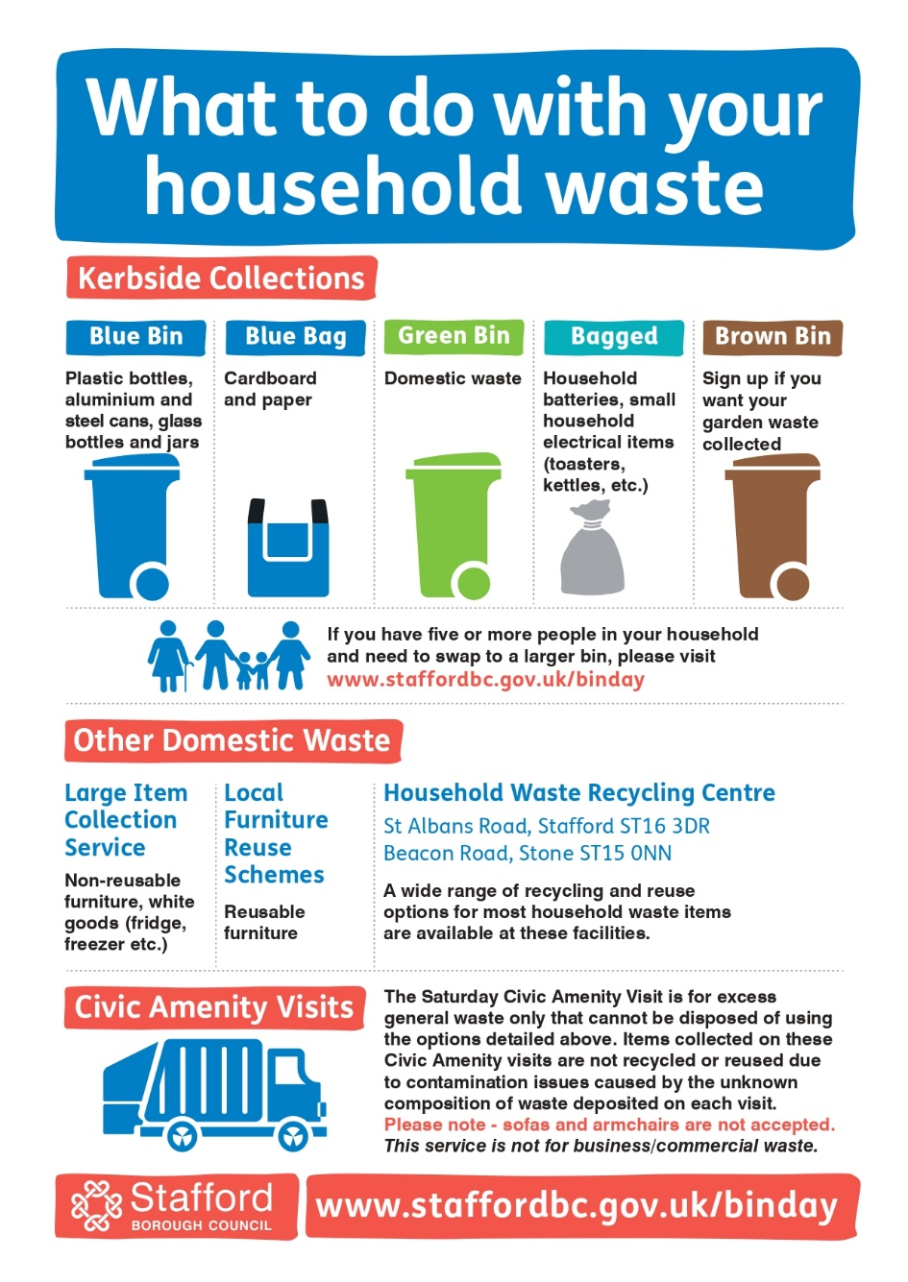

Site:                Village Hall Car Park, Bradley  
Dates:             24 February, 25 May, 17 August, 23 November  
Times:            09.00-10.00

Site:                Almshouse Croft (cul-de-sac), Bradley  
Dates:             24 February, 25 May, 17 August, 23 November  
Times:            10.15-11.15  
  
**Please be aware that, due to a change in legislation in 2023, they do not accept sofas or armchairs at the Civic Amenity Visits.  This is due to legislation around Persistent Organic Pollutants (POPs) which are found in soft furnishings, these items cannot be crushed (as they would be in the collection vehicle) and need to be collected separately, either by arrangement with Stafford Borough Council or taken to designated containers at the Household Waste Recycling Centres in Stafford and Stone.**