**Finance Report 14th November 2023**

**Item 10 Finance**

1. Payment approval – Finance report circulated before the meeting.



1. Office expenses summary – Finance report circulated before the meeting.



1. Budget summary – Finance report circulated before the meeting. – page 2
2. Bank reconciliation – Finance report circulated before the meeting. – page 3
3. Draft budget for 2024/25 – Finance report circulated before the meeting. – page 4
4. Approve updated NJC salary rates for 2023/24. Backdated from 1st April 2023.



**Bank reconciliation as at 9.41am - 14th November 2023**

Balance as per statement £34,128.00

Less payments till to be made £0

Total as per cashbook £34,128.00



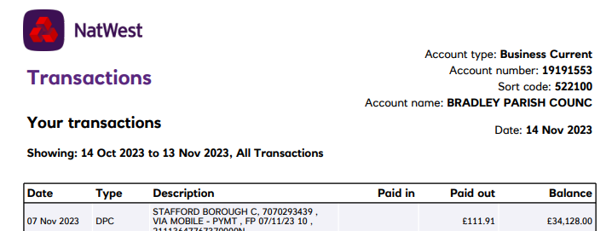

Signed __________________________________

Date ____________________________________

Signed __________________________________

Date ____________________________________

