Minutes of the Parish Council meeting held on
Tuesday 14th November 2023 at 7.30pm at
Bradley Village Hall, Church Lane, Bradley ST18 9DY

Attendees
Cllr P Oxley (Chairman) Cllr M Rossi (Vice Chairman) Cllr T Luck Cllr M Newman Cllr M Yarwood Cllr R Turner Cllr L Phillips
Cllr M Winnington – SCC Clerk – Nikola Evans PCSO 16750 Patrick Wright
1 | To receive Apologies – Cllr Jack Rose, SBC
2 | Minutes of the last meeting – 12th September 2023 - RESOLVED to accept as a true record by all that attended.
3 | Declaration of Interests on agenda items – None received
4 | To adjourn parish council meeting to allow for public participation  PCSO Patrick Wright introduced himself and gave a small report on how people can report crime. He encouraged people to report crime even if it seems futile; reporting crime enables the police to build up a picture crime in the area.  - 999 for an emergency,  - 101 to report a crime that has already happened or on line, on the Staffordshire police website https://www.staffordshire.police.uk/ro/report/ocr/af/how-to-report-a-crime/ .  - log onto Staffordshire police’s website to get up to date information regarding crime. https://www.staffordshire.police.uk/area/your-area/staffordshire/stafford-borough/south-west-stone/about-us/top-reported-crimes-in-this-area  - Receive the latest community safety information alerts about what's happening in your local area by registering for Staffordshire Smart Alert. https://www.staffordshire.police.uk/advice/advice-and-information/wsi/watch-schemes-initiatives/as/staffs/staffordshire-smart-alert/
5 | To receive an update on matters arising from previous minutes  - Dog Waste Bin – Malthouse Lane – RESOLVED The bin has been purchased and the parish council are in receipt; it will be installed shortly  - Betty Metcalf memorial – Cllr M Rossi – ROSOLVED in conjunction with The Bradley Trust; a tree and plaque have been installed, the location is between Malthouse Lane and Elm Drive by the footpath, for those wishing to view.  - Book swap – Church. – RESOLVED Clerk to speak with Village Hall administration to see if access times can be given, and if they would like the parish council to publicise. Also, to enquire whether there is a possibility of getting usage statistics.  - Sustainability newsletter / leaflet – RESOLVED Cllr L Phillips to work with the clerk to produce a webpage on the parish council’s website, providing information to members of the public. The parish council approved access to the website for Cllr Phillips.  - Traditional wooden black and white fingerposts – RESOLVED – fingerposts have been cleaned by Cllr Rossi and Cllr Luck, the broken fingerpost has been removed by Cllr Turner and the clerk will chase developers for Chapel Lane fingerpost, The Old Cottage. 21/34168/FUL. Cllr T Luck will look into the cost of replacing any if needed.  - Better signage at Bradley Lane/A518 “NOT suitable for heavy goods vehicles” – RESOLVED, Cllr M Winnington has approved the new signage to come out of his fund, it will be installed by March 24.
6 | To receive report on outstanding planning applications  Application Number Site Address Proposed Development Action  21/35264/FUL Foster Foliage Glamping Site Awaiting decision  22/35686/FUL Finney’s House Holiday Lodges Awaiting decision  22/36173/FUL Land at Holly Lane New access Awaiting decision  21/34168/FUL The Site of The Old Cottage, Almshouse Croft, Bradley Stafford Amendment to plans – this plan has now been changed back to the original plan. Building regulations stated they had visited site and were happy with current safety Awaiting decision
7 | Consideration of new planning applications - None
8 | To discuss village maintenance - 2024, areas include – Malthouse Lane x2 areas, Holly Lane, Elm Drive and the Corner of Church Lane & Bradley Lane. – Clerk/Chairman to report  RESOLVED to accept the quotation given by JWH Grounds Maintenance. The parish council will monitor it over 2024 to see if more cuts are required. The parish council were advised Wells Dairy may be able to offer a contribution to the cost of village maintenance. Clerk to contact Wells Dairy and confirm.
9 | To receive reports on any new footpath, village maintenance or highways issues  Clerk to report the following issues:  - Gulley’s of A518, first bend by Alstone Lane, needs clearing, due to the area being prone to flooding during the winter.
10 | Finance – RFO  - Payment approval – Finance report circulated before the meeting. APPROVED, also APPROVED to reimbursed Cllr M Rossi for Tree ties and concreate @ £18.80, clerk to arrange payment.  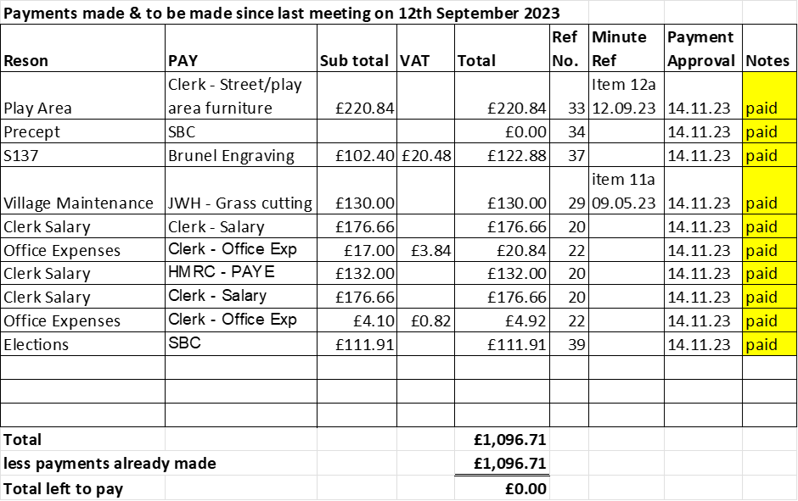  - Office expenses summary – Finance report circulated before the meeting. – APPROVED  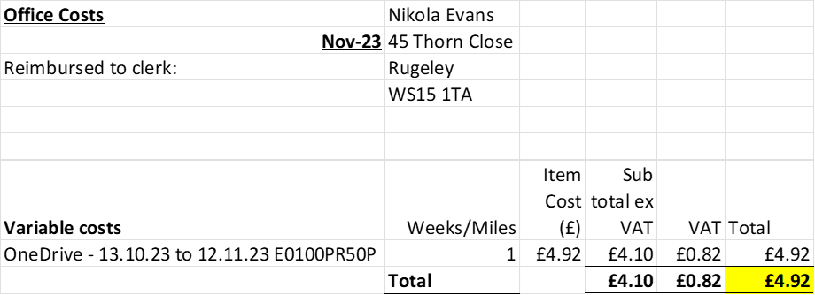  - Budget summary – Finance report circulated before the meeting. - APPROVED  - Bank reconciliation – Finance report circulated before the meeting. – APPROVED  - Draft Budget for 2024/25 and agree precept request. – Deferred to next meeting in January, clerk to check with auditor, how much reserve funds are required.  - To approve request for £214.20 towards defib maintenance costs by Dr Graham Parlane. – RESOLVED to approve, clerk to make arrangements for payment.  - To approve 2023/24 local governments services, pay agreement. – RESOLVED to accept and pay salary backpay from 1st April 2023.
11 | To discuss and approve policies.  - Social media policy – circulated before the meeting – RESOLVED, adopted  - Home working policy – circulated before the meeting – RESOLVED, adopted  - To consider taking the Civility and respect Pledge - https://www.nalc.gov.uk/our-work/civility-and-respect-project – RESOLVED, clerk to take the pledge.  - civility and respect model councillor officer protocol guide – circulated before the meeting – RESOLVED, adopted
12 | To discuss and resolve to meet the criteria for General Powers of Competence.  The parish council RESOLVED to agree it meets the criteria for general powers of competence and will reaffirm at the next relevant meeting. (Annual Parish Council Meeting that takes place in an election year)
13 | To discuss and approve a tree to be planted in the play area for the Friendship circle.  - Discuss area to plant – RESOLVED Cllr Rossi will get in touch with the Bradley Trust to agree a suitable place  - Discuss and approve for the parish council to purchase the plaque and be reimbursed from the remaining friendship circles funds. – RESOLVED clerk to purchase plaque and post, then seek reimbursement from the left-over Friendship Circle funds held by the administrator.
14 | To discuss proposal from Cllr Rossi to replace the noticeboard at Almshouse Croft.  The parish council agreed to look at replacing both noticeboards. Clerk to obtain quotes and present to the parish council at the next meeting in January 2024. Clerk advised cost would likely be around £2,000
15 | To discuss and approve actions for the Bradley Community Plan  - Reinstating the red telephone box – deferred to next meeting in January 2024  - Improve signposting of public footpaths – Clerk to contact Haugton or Gnosall Parish Council clerk. It is believed they have done some work on the public footpaths within their area. It was suggested a footpath committee could be organised, to walk the routes and make a list of the issues.  - Gateway features to the village – Clerk to obtain quotes and a site visit with Highways ready for the next meeting in January. Clerk advised possible cost would be around £3,000 for three gateways. Highways advised the parish council would need to fund.  - To discuss and agree next items off the action plan for discussion – Populating the current parish council website with links to other services, to create a one-stop website for the community.
16 | Councillor Information and items for the next Agenda  Cllrs are invited to give reports on parish issues which do not require a resolution. – None received.
17 | To agree date of next meeting – 9th January 2024 @ Bradley Village Hall, from 7.30pm  Future meeting dates – 12.03.24, Annual PCM 14.05.24, Annual Parish Meeting TBC, 9.07.24, 10.09.24, 12.11.24
18 | Meeting Closed – 21:30pm

