**Appendices 1 – 7 – 09.05.23**

**Item 8**

1. Potholes in Littywood Lane – repaired w/c 18th April
2. Broken drain in Barton Lane – No further update
3. Giveaway sign at the end of Bradley Lane – Done
4. Cost of buying further dog fouling bins for the village – Cllr Luck was investigating this.
5. Replacement of Dog Fouling signs, along Barton Lane – Cllr Rossi to update
6. Air pollution caused by the burning of tyres and potentially other items at the Old Nursey Site – The Environmental agency advised, we as a parish council cannot take action, reports must come from individuals around the village. All the environmental agency can do is issue a £50 fine, however if a log can be put together of all incidents (to include times, dates and pictures) to identify a pattern of what’s being burnt, a deeper investigation could be done and they can possibly investigate them for Tax purposes.
7. Erection of the wall for the entrance to the holiday lodges – Contacted Diane Firkins, Highways. She advised a highway report to be raised, an inspector will attend site to look at the safety implications or she will be happy to do a site visit and take it from there.

**Appendix 1**

|  |  |  |  |
| --- | --- | --- | --- |
| **Application Number** | **Site Address** | **Proposed Development** | **Action** |
| 21/34176/HOU | Bradley Hall Farm | Conversion and reinstatement of derelict building | Awaiting decision |
| 21/35263/FUL | Fosters Foliage | Change of use, self-storage containers | Awaiting decision |
| 21/35264/FUL | Foster Foliage | Glamping Site | Awaiting decision |
| 22/36312/FUL | Wells Farm Dairy | New maintenance and storage building | Awaiting decision |
| 22/35686/FUL | Finney’s House | Holiday Lodges | Awaiting decision |
| 21/34176/HOU | Bradley Hall Farm, Mitton Road | Planning amendment | Awaiting decision |
| 22/36173/FUL | Land at Holly Lane | New access | Awaiting decision |
| 22/36472/FUL | Dearnsdale Farm | Steel framed extension | Awaiting decision |
| 21/36472/FUL | The old Cottage site | Amendment to plans – this plan has now been changed back to the original plan. Building regulations stated they had visited site and were happy with current safety | Planning application reference not recognised, need address |

**Appendix 2**

|  |  |  |  |  |
| --- | --- | --- | --- | --- |
| **Bradley PC Action plan** | | | | |
|  | **Document** | **Document Name** | **Priority** | **Notes** |
| 1 | Risk Assessment |  | By May Meeting | In progress - Done |
| 2 | VAT reclaim |  | ASAP | I can only claim VAT back for the last 4 years, from April 2019. I will have to go through all the invoices for each financial year to:  a) separate the VAT from the invoice total b) obtain the VAT registration numbers for each company  c) apply online for a VAT reclaim  In progress £1,529.56 total to reclaim |
| 3 | Insurance |  | Renewal due 1.06.23 | In progress - Checked current insurance, whilst it does include the necessary cover for employers’ liability and public liability, the values for contents are not sufficient. Increased to £500 for office equipment & £30,000 for playground equipment and other assets. I am unable to determine an exact figure until the asset register is completed. The insurance is due for renewal on 1.06.23. I have requested two quotes, one from our current provider and another for comparison. Zurich £437 & Gallagher £610.45 |
| 4 | Policy check/review | Standing Orders | by May meeting | Done |
|  |  | Financial Regulations | by May meeting | Done |
|  |  | Complaints Procedure | ASAP | Done |
|  |  | Grievance Policy | ASAP | Done |
|  |  | Data Protection Policy | ASAP | Done |
|  |  | Freedom of Information Policy | ASAP | In progress – It’s the law to pay data protection fees – Registered - application number C1332133 £40 reduced to £35 if we pay by DD. Set DD to come out of clerks account for this year. |
|  |  | Social Media Policy | ASAP |  |
|  |  | Anti bullying and Harassment Policy | ASAP | Who owns the defis? Where they donated to Bradley PC? |
|  |  | Asset Register | ASAP | In progress |
|  |  | Equality and Diversity Policy | ASAP |  |
|  |  | Homeworking Policy | ASAP |  |
|  |  | Lone Working Policy | ASAP |  |
|  |  | Training and Development Policy | ASAP |  |
|  |  | Publication Scheme | ASAP |  |
|  |  | Grant Awarding Policy and Procedure | ASAP |  |
|  |  | Scheme of Delegation | by May meeting | Done |
|  |  | Disciplinary Policy | ASAP | Done |
| 5 | HMRC PAYE Basic Tools | Download and Register | ASAP | In progress - waiting for registration number |
| 6 | Digitalise the Accounts |  | ASAP | Done |
| 7 | Bank Account Access |  | ASAP | In progress |
| 8 | Register for Online Banking |  | non urgent | In progress - Waiting for addition of new signatories, removal of old signatories, contact details to be updated before registering for online access |
| 9 | Contractors for 2023 | JWH Ground Maintenance |  | To call contractor to request 2023 quotation |
| 10 | Business use of home |  | at a later meeting of the council. | To be discussed – proposal - £26 per month for full time hours of 37.5 = 0.69p x 4 hours per week = £2.77 x 5 = £144 per year to be paid either £144 every year in March or £12 per month. Hilderstone PC, of similar size pay £168 a year. |
| 11 | Purchase PC/Laptop |  | ASAP | Will need one to carry out the parish council administration duties. Currently using Doxey PC, however HMRC Basic tools for payroll needs to be registered on its own pc/laptop. You can’t have two HMRC basic tool accounts on the same computer. |
| 12 | Sort Hard copy documents |  | As and when – non urgent | Done |

**Appendix 3**

**Item 16 Finance report 9.05.23**

1. Payment approval



**Appendix 4**

1. Office Expenses summary



**Appendix 5** – c) Budget Summary



**Appendix 6** – d) bank reconciliation

Balance as per last statement received on 28th March 2023 £24,163.97

Plus, income £7,156.50

Less payments £978.43

Total as per cashbook £30,342.04



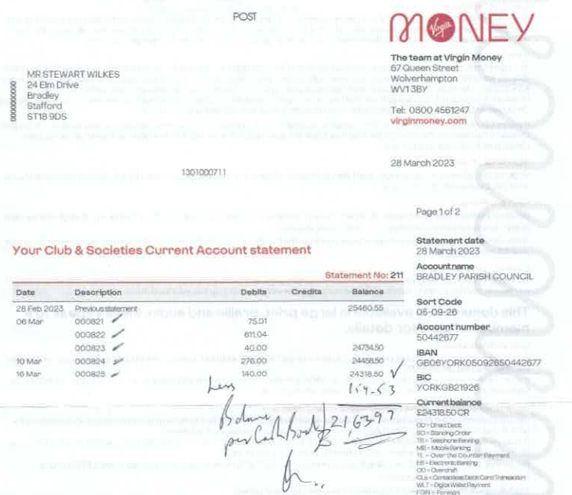Written balance on the statement should read £24,318.50 less uncashed cheque £154.53 giving a total of £24,163.97 carried forward to 2023/24 – clerk does not have access to the bank at this present time. Updated balance received by phone on 20.04.23 was £31,320.47.

Signed ____________________________ Date __________________________

Signed ____________________________ Date __________________________

**Appendix 7**

e) End of year bank reconciliation for 2022/23 – please note not done by RFO, done by the Internal auditor.

